# Introduction to Hive

* Developed by Facebook in 2007
* Dataset grew from 15TB to 700TB
* RDBMS Datawarehouse was taking too long
* Moved data into scalable open source hadoop env
* Vision: Bring familiar database concepts to the unstructured world of Hadoop while still maintaining Hadoop’s extensibility and flexibility
* Open sourced in Aug 2008
* Used @ Facebook for reporting dashboards and ad-hoc analysis

## Describe what Hive is, what it’s used for and

* Data Warehouse system built on top of hadoop
  + Takes advantage of distributed processing
* Facilitates easy data summary, ad-hoc queries, analysis of large datasets in hadoop
* Hive provides SQL interface (HQL) for data stored in Hadoop
  + Familiar and widely known syntax
  + Data Definition Language and Data Manipulation Language
* HQL queries implicitly translated to one or more Hadoop MapReduce jobs(s) for execution
  + Saves you from having to write MapReduce programs
  + Clear separation of defining the what you want from the how to get it
* Hive provides mechanisms to project structure onto hadoop datasets
  + Catalog (‘Metastore’) maps file structure to a tabular format

### Hive is not

* A full database but fits alongside your RDBMS
* Not real time processing system
  + Best for heavy analytics and large aggregations (Data Warehousing
  + Latencies are much higher than RDBMS
  + Schema on Read
    - Fast loads and flexibility – cost of query time
    - Use RDBMS for fat run queries
* Not SQL-92 compliant
  + Does not provide row level inserts, updates, or deletes
  + Doesn’t support transactions
  + Limited subquery support
* Query optimization is a work in progress
* See HBase for rapid queries and row-level updates and transactions

## How Hive compares to other similar technologies?

### Java

* Word count MapReduce example
  + Lists words and number of occurrences in a document
  + Takes 63 lines of Java code
  + Hive takes 7 lines

### Pig

* High level programming language (data flow language)
  + Higher learning curve for SQL programmers
* Good for ETL, not as good for ad-hoc querying
* Powerful transformation capabilities
* Often used in combo with HIVE

## Describe the Hive architecture

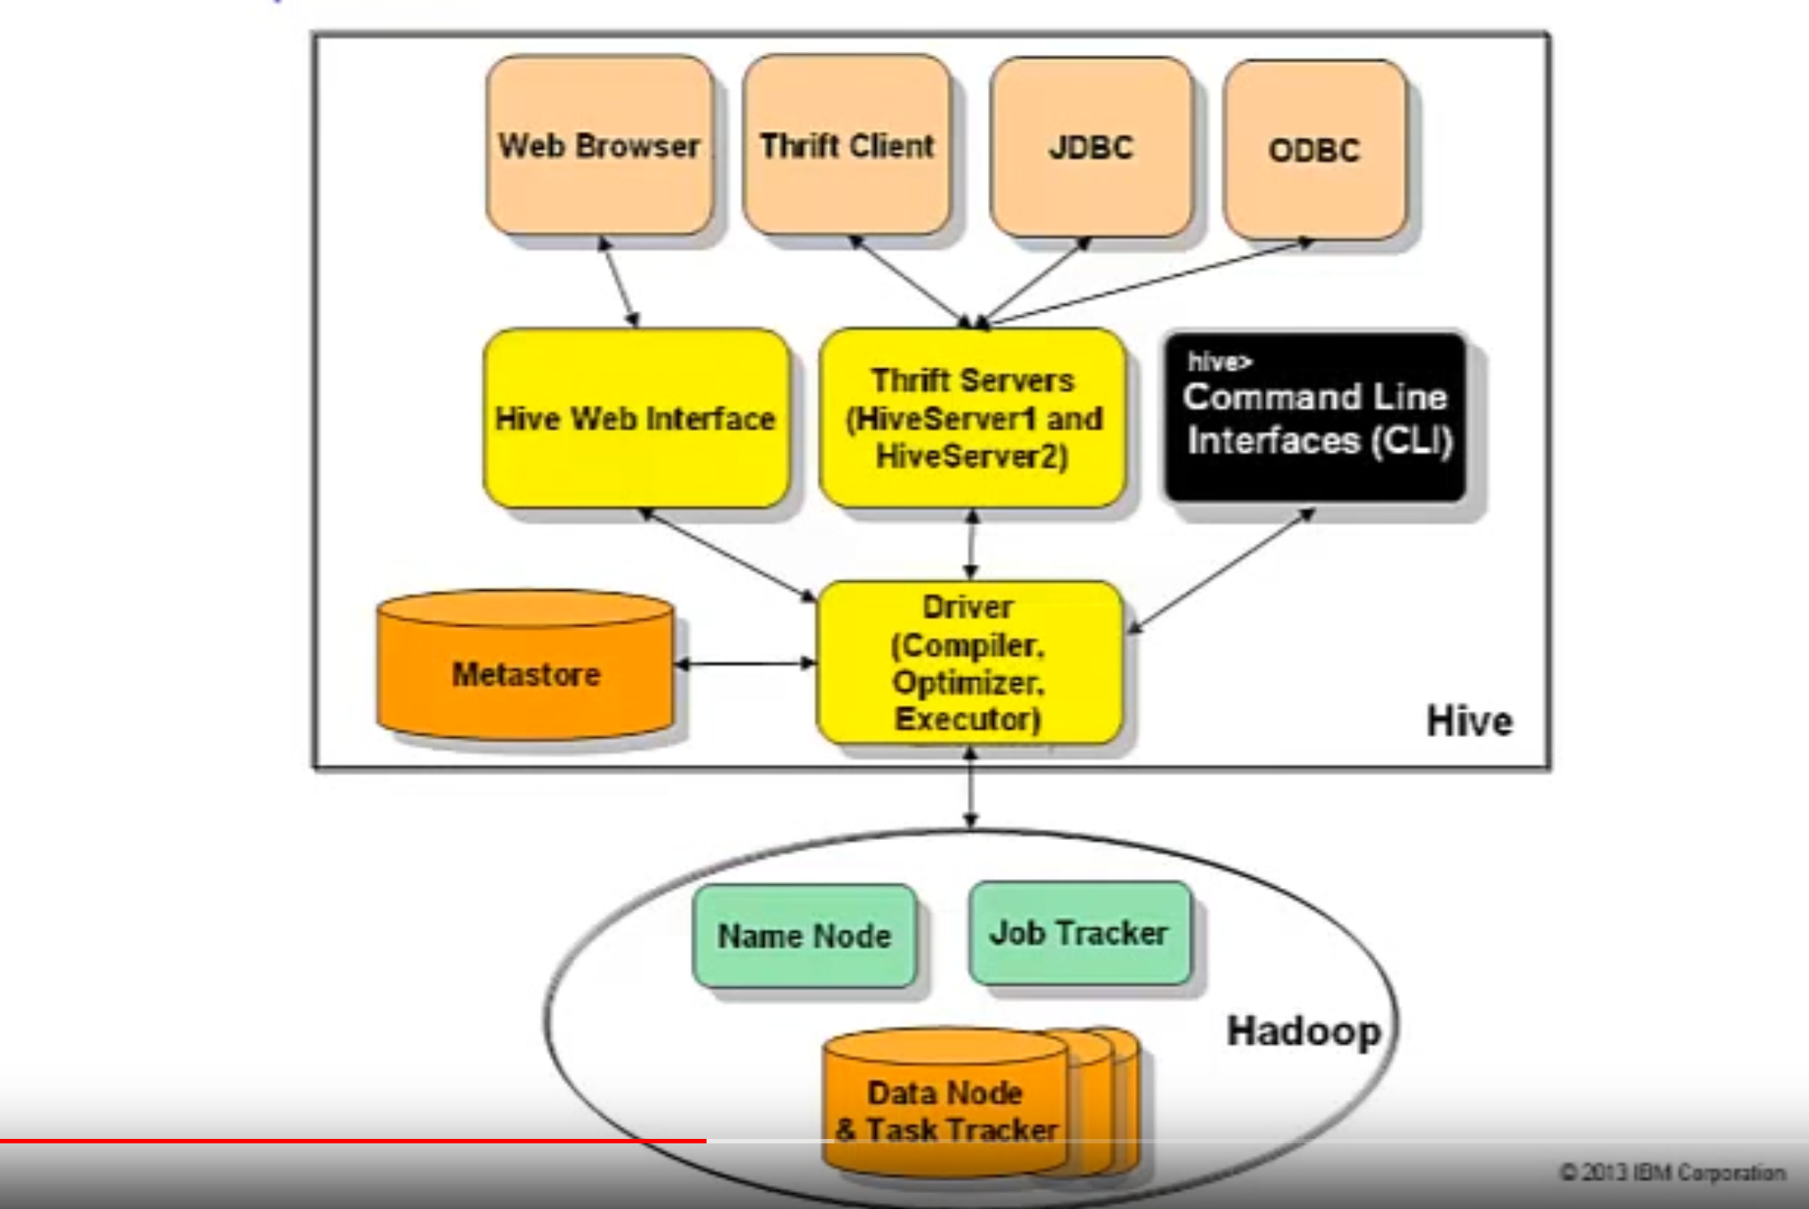

Now let’s take a look at Hive’s architecture. There are a variety of different ways that you can interface with Hive.

You can use a web browser to access Hive via the Hive Web Interface.

You could also access Hive using an application over JDBC, ODBC, or the Thrift API, each made possible by Hive’s Thrift Server referred to as HiveServer.

## Describe the main components of Hive

### HiveServer2

HiveServer2 was released in Hive 0.11 and serves as a replacement for HiveServer1, though you still have the choice of which HiveServer to run or can even run them concurrently. HiveServer2 brings many enhancements including the ability to handle concurrent clients and more. Hive also comes with some powerful Command Line interfaces (often referred to as the “CLI”).

### Beeline

The introduction of HiveServer2 brings with it a new Hive CLI called Beeline, which can be run in embedded mode or thin client mode. In thin client mode, the Beeline CLI connects to Hive via JDBC and HiveServer2. The original CLI is also included with Hive and can run in embedded mode or as a client to the HiveServer1.

### Metastore

Hive comes with a catalog known as the Metastore. The Metastore stores the system catalog and metadata about tables, columns, partitions and so on. The Metastore makes mapping file structure to a tabular form possible in Hive.

#### Embedded

In process metastore, in process database

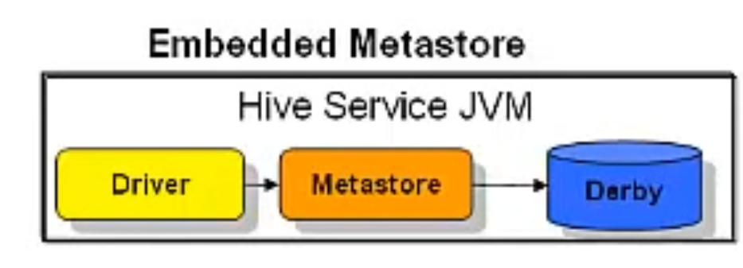

#### *Local*

In process Metastore, out of process database

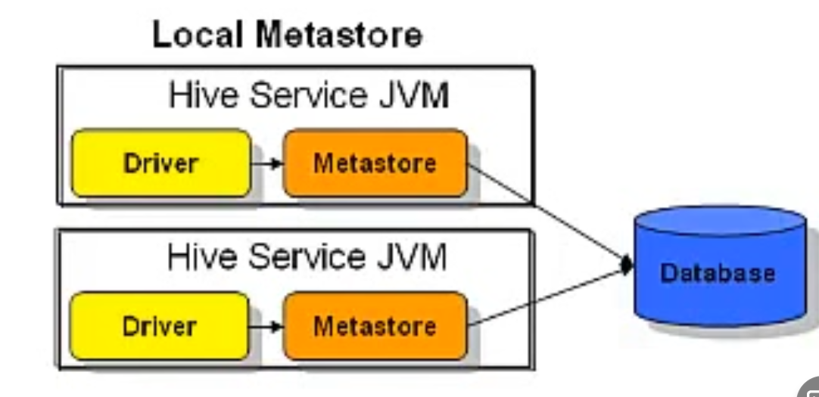

#### Remote

Out of process Metastore, out of process database

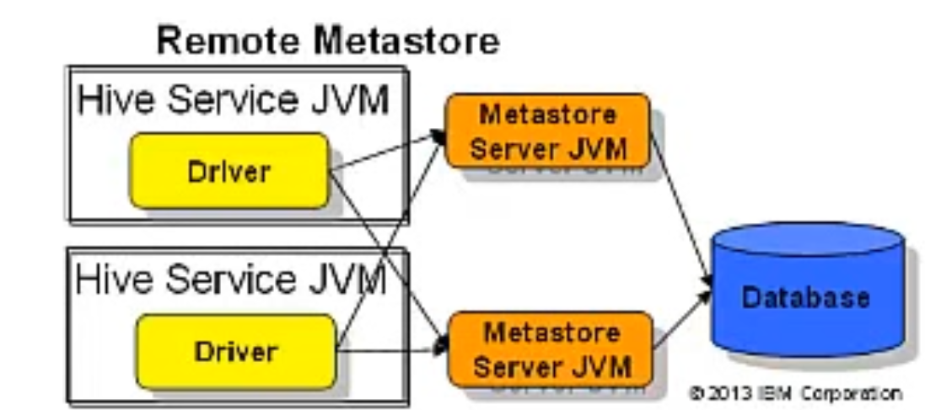

* If Metastore not configured – Derby database is used
  + Only allows 1 user at a time
* Can be configured to use a wide variety of storage options (DB2, MySQL, Oracle, XML files, etc) for more robust Metastore

### HCatalog

A newer component of Hive is called HCatalog. HCatalog is built on top of the Hive Metastore and incorporates Hive's DDL. HCatalog provides read and write interfaces for Pig and MapReduce and uses Hive's command line interface for issuing data definition and metadata exploration commands. Essentially, HCatalog makes it easier for users of Pig, MapReduce, and Hive, to read and write data on the grid.

The Hive Driver, Compiler, Optimizer, and Executor work together to turn a query into a set of Hadoop jobs.

### Driver

The Driver piece manages the lifecycle of a HiveQL statement as it moves through Hive. It maintains a session handle and any session statistics.

### Query Compiler

The Query Compiler compiles HiveQL queries into a DAG of MapReduce tasks.

### Execution Engine

The Execution Engine executes the tasks produced by the compiler in proper dependency order. The Execution Engine interacts with the underlying Hadoop instance, working with the Name Node, Job Tracker and so on.

### Directory Structure

#### Lib

* $HIVE_HOME/lib
* Location of JAR files
* Contain the actual java code that implements the HIVE functionality

#### Bin

* $HIVE_HOME/bin
* Location of scripts and services

#### Conf

* $HIVE_HOM/conf
* Location of configuration files

### CLI

* Most common way to interact with HIVE
* From shell you can
  + Perform queries, DML, DDL
  + View and manipulate table metadata
  + Retrieve query explain plans (execution strategy)
* Hive beeline shell and original CLI are located in
  + $HIVE_HOME/bin/hive

## List interesting ways others are using Hive

### CNET

Used for data mining, internal log analysis, and ad hoc queries

### Digg

Used for data mining, internal log analysis, R&D, and reporting/analytics

### Grooveshark

Used for user analytics, dataset cleaning, and machine learning R&D

### PaperTrail

Used as a customer facing analysis destination for our hosted syslog and app log management service

### Scribd

Used for machine learning, data mining, ad hoc querying, and internal and user facing analytics

### VideoEgg

Used as a core database for our data warehouse where we track and analyze all the usage data of the ads across our network

# Hive DDL

## Create databases and tables in Hive, while using a variety of different Data Types

### Organized

#### Databases

First data is organized into Databases which are namespaces that separate tables and other data units from naming conflicts.

#### Tables

Next data is organized into tables which are homogenous units of data that have the same schema.

#### Partitions

Data can then be organized into partitions, though this is not a requirement. A Partition in Hive is a virtual column that defines how data is stored on the file system based on its values. A table can have zero or more partitions.

#### Buckets

Finally, in each partition, data can be organized into Buckets based on the hash value of a column in the table. Again, note that it isn’t necessary for tables to be partitioned or bucketed in Hive, however these abstractions allow the system to prune large quantities of data during query processing, resulting in faster query execution and reduced latencies.

### Stored

Now that you’ve seen that Hive logically breaks data out into Databases, Tables, and Partitions, let’s look at how this data is physically stored.

#### Data Files

* Data files in Hive are stored right in the Hadoop file system.
  + A variety of different storage and record formats can be used for your data.
  + The internal format of your data can really vary from table-to-table depending on how you want to set things up.

#### Warehouse directory

* In Hive your data is stored in the warehouse directory as specified in your configuration file unless you override this location.
* Listed on this slide is an example of how Hive stores databases, tables, partitions, and buckets.
* You can see that a directory is created for a database and inside that is a subdirectory for a table, that itself contains a subdirectory for a partition. The actual file that holds the data would be stored inside that partition folder in this example.
* If we chose to bucket the table in this example, then our data would be divided up into multiple bucket files and stored inside of the partition directory.
* In this example our data is stored in 32 bucketed data files inside of the partition directory.
* When creating this table, we would specify the number of buckets – it is not a randomly assigned number.

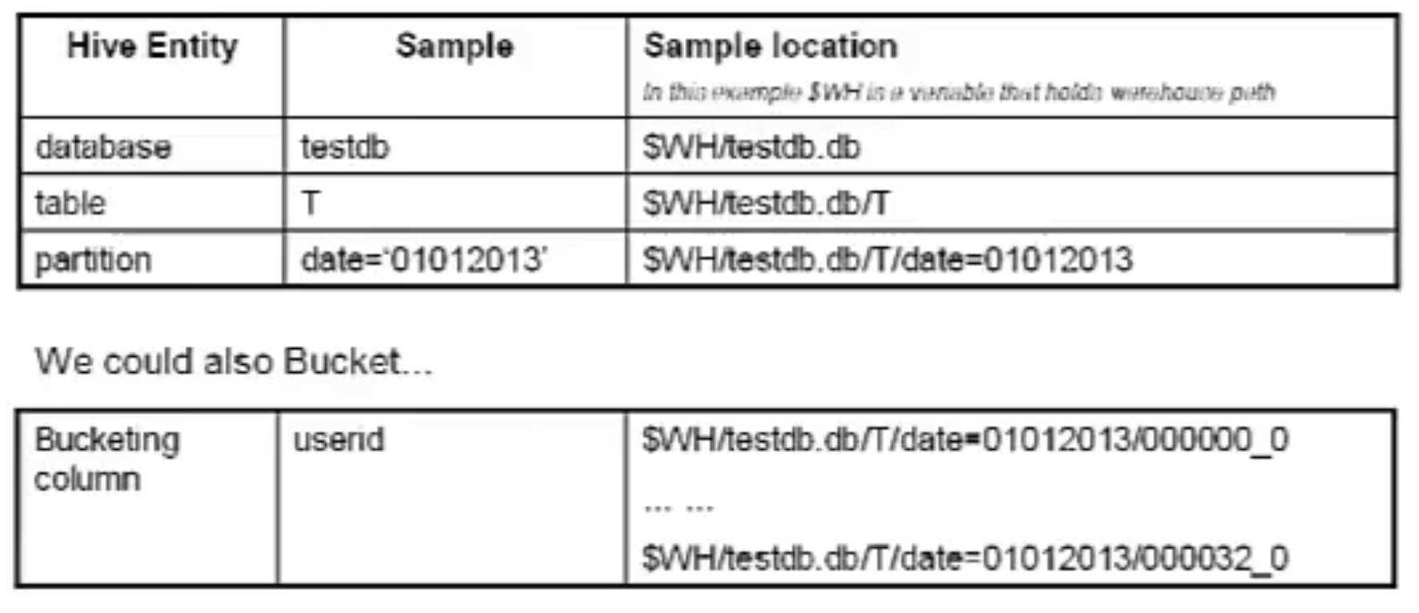

## Run a variety of different DDL commands

### Create Database

Creating a database in Hive is easy. It can be as simple as typing three words – “create database” followed by the name youPrimi’d like the database to be called. There are additional options you can add to your basic Create statement, such as specifying the location you’d like the database to be created - and adding a comment to the metadata for that database.

* CREATE DATABASE mydatabase
* LOCATION ‘/myfavorite/folder/’;
* COMMENT ‘this is my database’;
* WITH DBPROPERTIES(‘createdby’ – ‘bigdatauser’, ‘date’ – ‘2021-11-22’)

### Database show / Describe

* SHOW DATABASES;
* DESCRIBE DATABASE mydatabase;
* DESCRIBE DATABASE EXTENDED mydatabase;

### Database Use/ Drop / Alter

* Use mydatabase;
* DROP DATABASE IF EXISTS mydatabase;
  + -- Database directory is also deleted
* ALTER DATABASE mydatabase SET DBPROPERTIES (‘createdby’ – ‘bigdatauser2’);
  + – Only possible to update the DBPROPERTIES metadata

### Primitive Data types

* Integers
  + TINYINT
    - 1 byte
  + SMALLINT
    - 2 byte
  + INT
    - 4 byte
  + BIGINT
    - 8 byte
* Boolean
  + BOOLEAN – TRUE/FALSE
* Floating point numbers
  + FLOAT
    - Single precision
  + DOUBLE
    - Double precision
  + DECIMAL
    - Precise values and greater range than double
* String
  + STRING
    - Sequence of characters in a specified character set
  + VARCHAR
    - Specify length of character string (1-65355)
* Date/Tie types
  + TIMESTAMP
    - YYYY-MM-DD HH:MM:SS.ffff
  + DATE
    - YYYY-MM-DD
* Binary
  + BINARY
    - Array of bytes (similar to varbinary in RDBMS)
* On comparison Hive does implicit casting
  + Any integer to larger or two integer types
  + Float to Double
  + Any integer to Double

### Complex Data Types

Built up from primitives

* Array
  + Indexable lists containing elements of same type
  + Format: ARRAY <data_type>
  + Literal syntax example: array(‘user1’,’user2’)
  + Accessing Elements: [n] notation where n is an index into the array
* Structs
  + Collection of elements of different types
  + Format: STRUCT <col_name : data_type, …>
  + Literal syntax example: struct(‘user1’:’213’)
  + Accessing Elements: DOT (.) notation struct.field
* Maps
  + Collection of key-value tuples
  + Format: MAP<primitive_type, data_type>
  + Literal syntax example: map(‘business_title’. ‘CEO’, ’rank’.’1’)
  + Accessing Elements: [‘element name’] notation map[‘business_title’]
* Union
  + At any one point can hold exactly one of their specified data types
  + Format: UNIONTYPE<datatype, datatype, …>
  + Accessing element: use create_union udf (see hive docs)

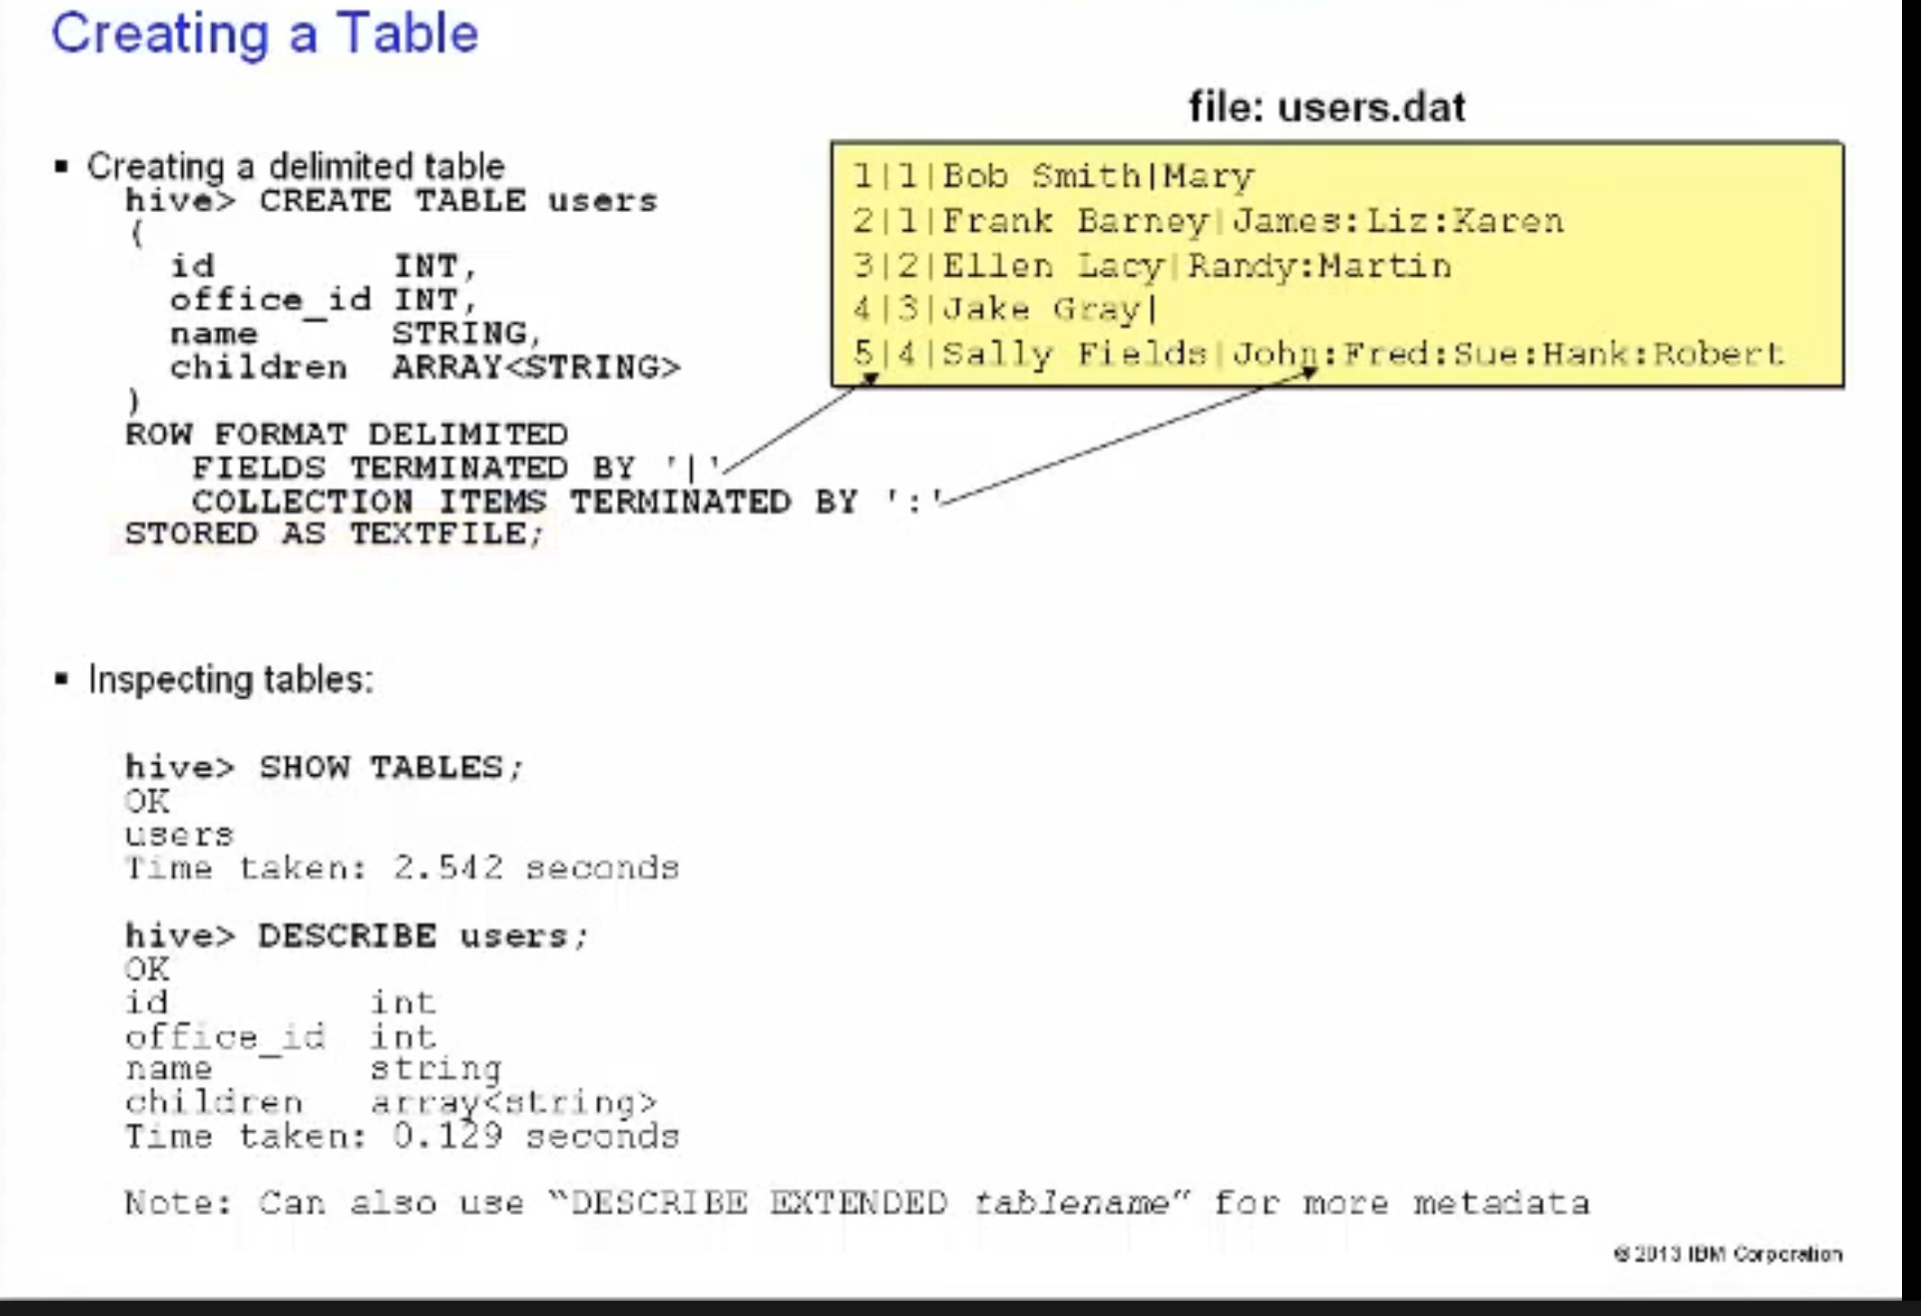

Now that we know what data types can be used in Hive, let’s look at an example of a simple Hive table being created with HQL. In this example a table named “users” is being created with 4 columns.

There is an ID column which is of the INT data type, along with an office_id column of the same type. There also is a name column that is of the String data type, and finally an array column called “children” which can hold String values.

We tell Hive that the fields in our rows are delimited by the pipe character. We then tell Hive that the collection items in the array field are terminated by the colon character. Finally, we explicitly specify that our data file is a plain text file.

Once our table is created, we can then run the “show tables” statement to see a listing of all the tables in our database. We can also use the “DESCRIBE” statement to view some metadata for a specific table. Further, we can use “DESCRIBE EXTENDED” to view additional table metadata.

## Use Partitioning to improve performance of Hive queries

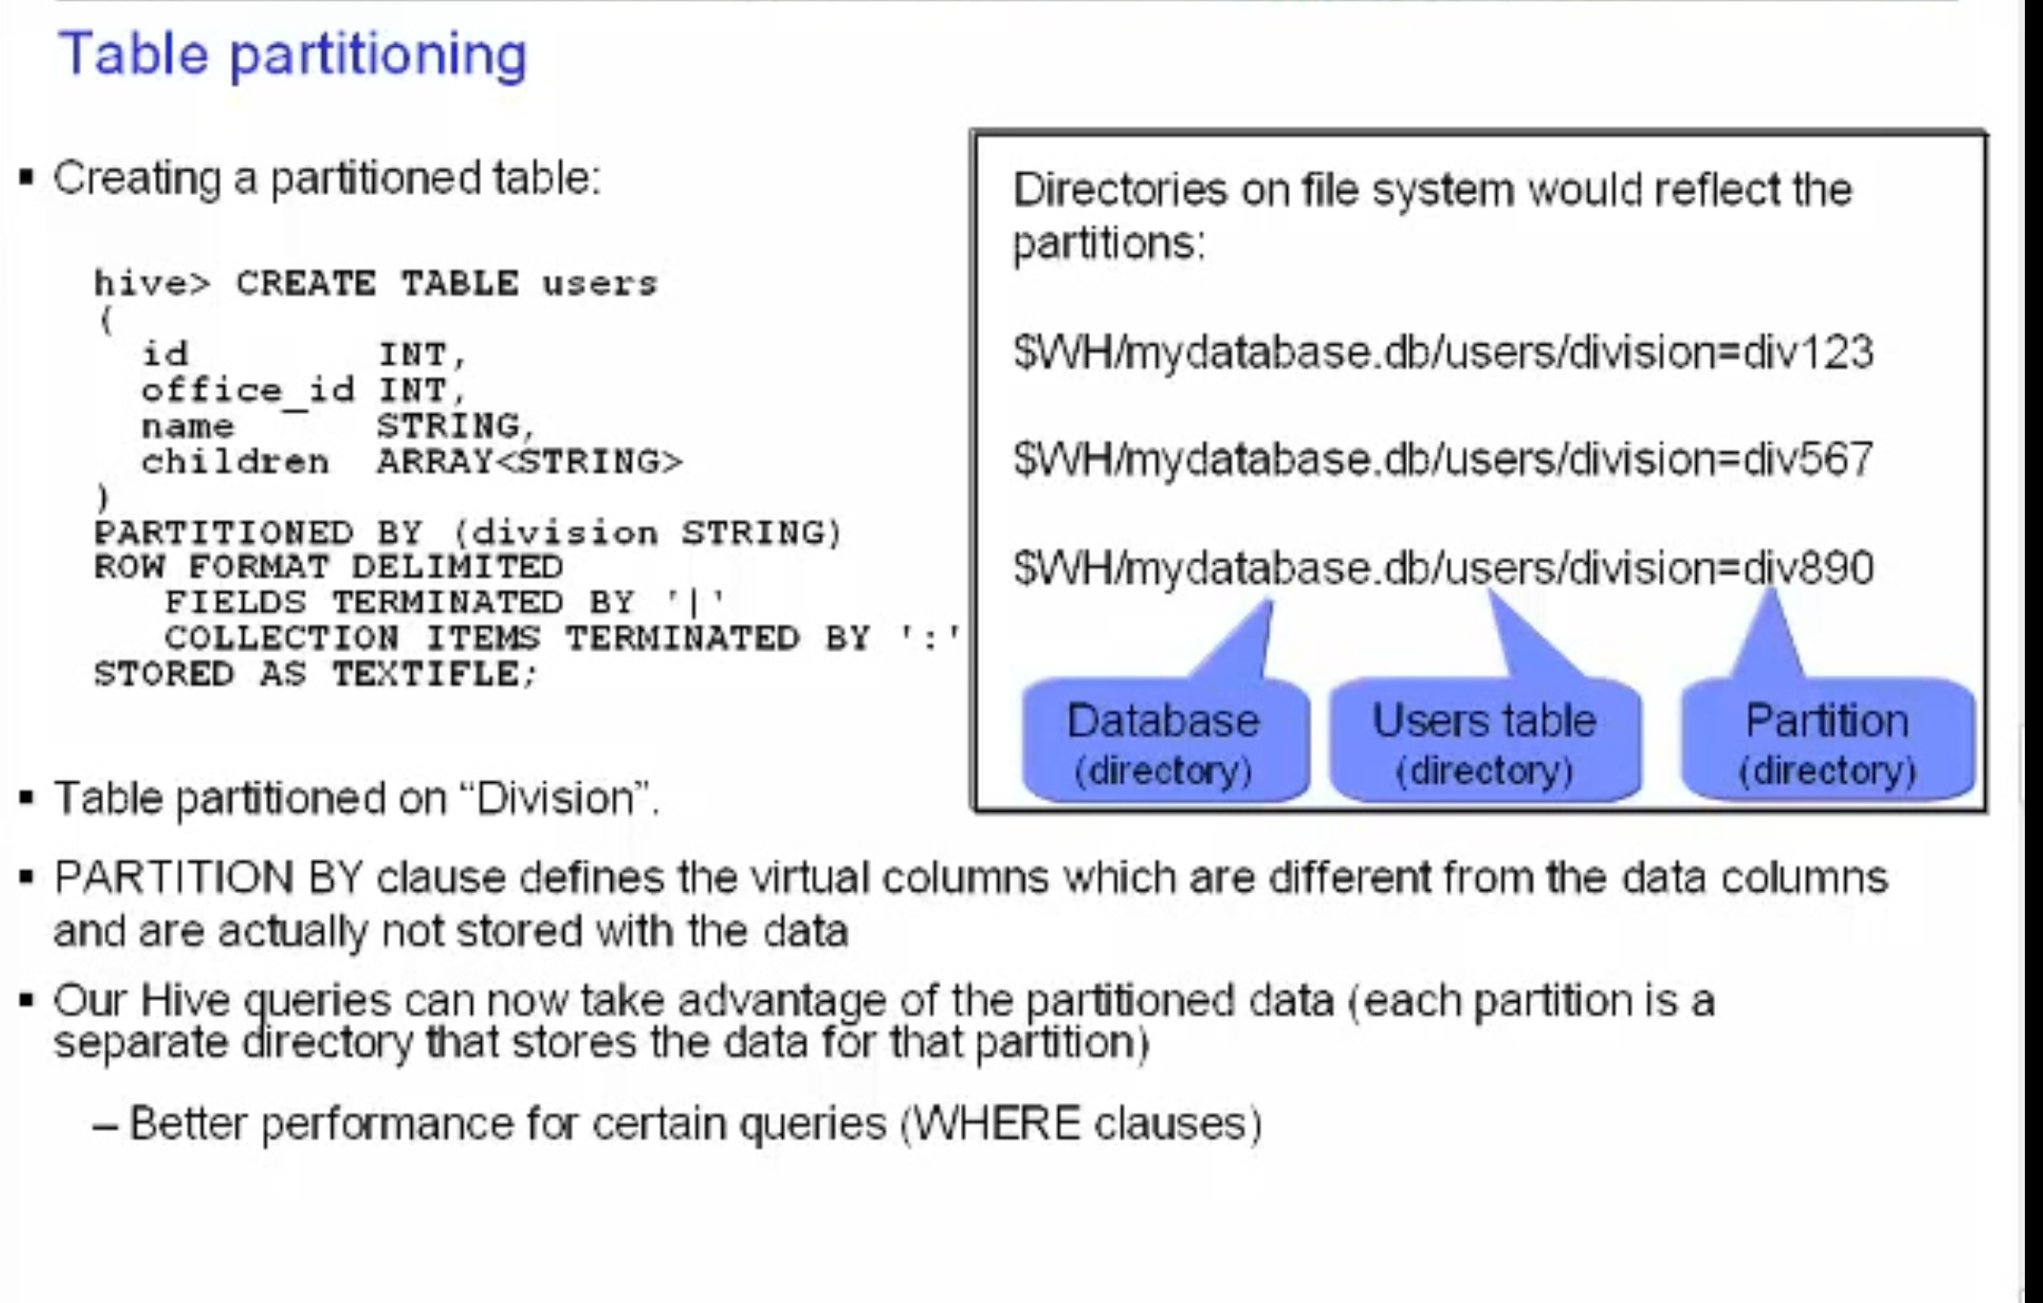 In this example, our new users table will now be partitioned on “division”, which we specify is of the String data type. We accomplished this by adding the PARTITION BY clause. Division will now be a virtual column – the division is not actually stored in the data file with the rest of the data.

Now that we have a partitioned table, once data is loaded in, our Hive queries will be able to take advantage of the fact that each partition is a separate directory that contains just that one partitions’ data on the file system. This will help us achieve better performance especially when running queries with WHERE clauses. The less data we need to read and process for a given query, the better, as we gain the benefit of reduced latency.

Inside the box on this screen you can get a feel for what the physical directory structure would look like for a table with 3 partitions. Down the Warehouse path we can see the directory for the database, the table, and the partition.

## Create Managed and External tables in Hive

### Managed Tables

* Default
* Hive controls the metadata and the lifecycle
* Data stored in sub directories within the hive.metastore.warehouse.dir location
* Dropping a managed table deletes the data in the table

### External tables

* Store table I a directory outside of hive
* Useful if sharing your data with other tools
* Hive does not assume it owns the data in the table
  + Dropping table deletes the tables metadata – not the actual ata
* Must add external and location keywords to create statement
  + CREATE EXTERNAL TABLE users
  + LOCATION ‘/path/to/your/data/’;

### Drop Alter Table

* DROP TABLE IF EXISTS users;
* ALTER TABLE users RENAME TO employees;
* ALTER TABLE users ADD COLUMNS (
  + Location STRING,
  + Age INT);
* Variety of others
  + Alter table properties
  + Alter storage properties
  + Alter partitions

### Indexes

* Goal: improve speed of query lookup on certain columns of a table
* Speed improved at cost of processing and disk space (index data stored in a another table)
  + CREATE INDEX table1_index ON TABLE table1 (column2) as ‘COMPACT’;
  + SHOW INDEX ON table1;
  + DROP INDEX table1_index on table1
* Variety of others
  + Bitmap
  + Etc

# Hive DML

## Load data into Hive

### From file

* Loading data from input file (Schema on Read)
  + - LOAD DATA LOCAL INPATH ‘/tmp/data/users/dat’
    - OVERWRITE INTO TABLE users
  + Local = source data on local file system
  + Data is copied to final location
  + Otherwise file is assumed to be on HDFS and is moved to final location
  + Hive does not do any transformations while loading data into tables
* Loading data into a partition requires a PARTITION clause
  + - LOAD DATA LOCAL INPATH ‘/tmp/data/users/dat’
    - OVERWRITE INTO TABLE users
    - PARTITION (‘country’ – ‘us’, ‘state’ – ‘NY’)
  + HDFS directory is created
    - /user/hive/warehouse/mydb.db/users/country=US/state=NY
    - Userny.dat file is copies to this HDFS directory

### From HDFS Directory

LOAD DATA IN PATH ‘/user/bigadmin/userdatafiles’  
OVERWRITE INTO TABLE users;

* Lack of LOCAL keyword means data is on HDFS file system
* Data is MOVED to final location
* All of the files in the directory are copies over into HIVE
  + Leaving out OVERWRITE means tiles will be added to the table
  + If target has file name collision, then new file will overwrite existing HIVE file

### From Query

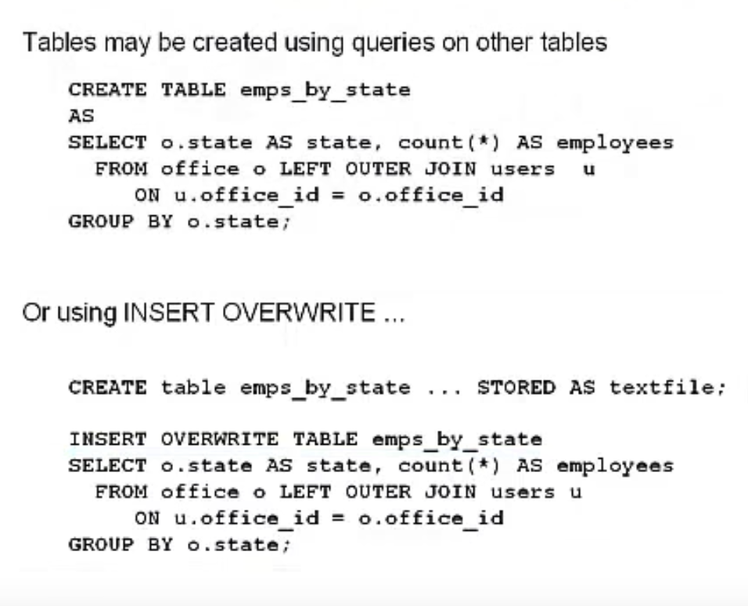

## Export data out of Hive

* If data files are formatted correctly just copy them out of HDFS
* Query results can be inserted into file system directories (local or HDFS)
* IF LOCAL keyword. Hive writes data to directory on file system

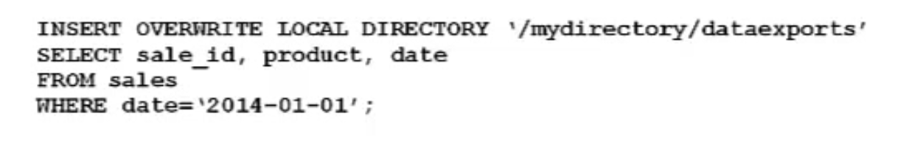

* Data written to file system is serialized as text w/ columns separated by ^A and rows separated by new lines
  + Non primitive columns serialized to JSON
  + Delimiters and file format may be specified
* INSERT OVERWRITE statements to HDFS is a good way to extract large amounts of data from HIVE
  + HIVE can write to HDFS directories in parallel from within a MapRedcue Job
* WARNING:
  + DIRECTORIES ARE OVERWRITTEN IF PATH EXISTS

## Run a variety of different HiveQL DML queries

## SELECT FROM

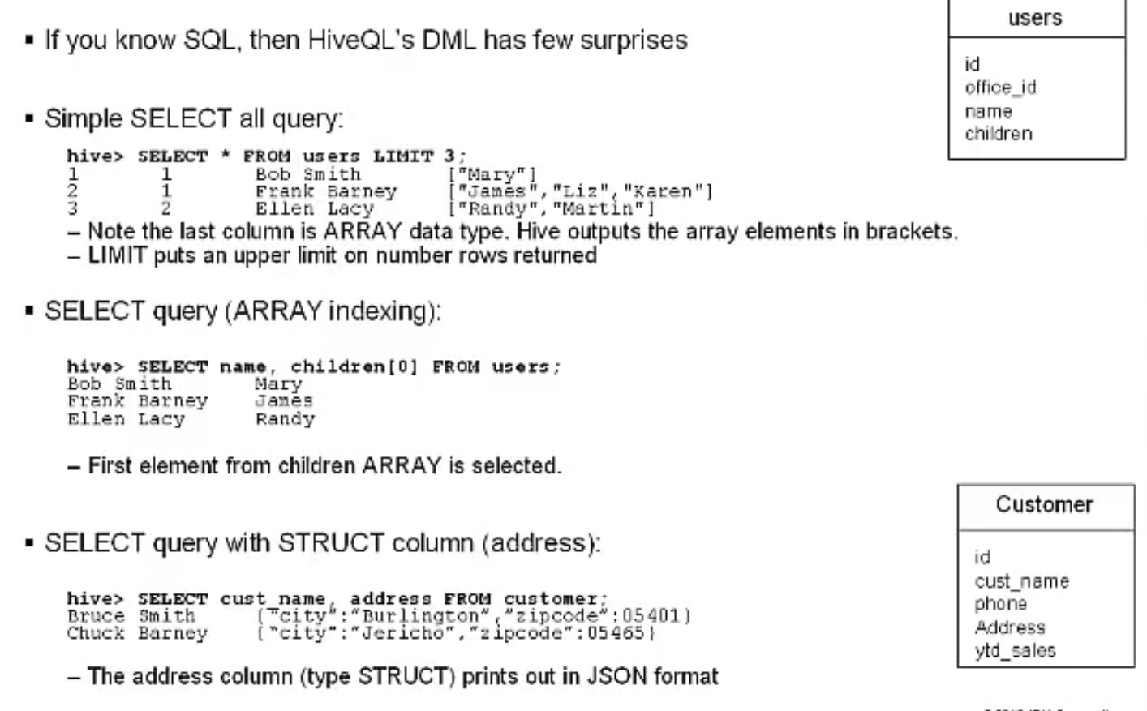

### WHERE

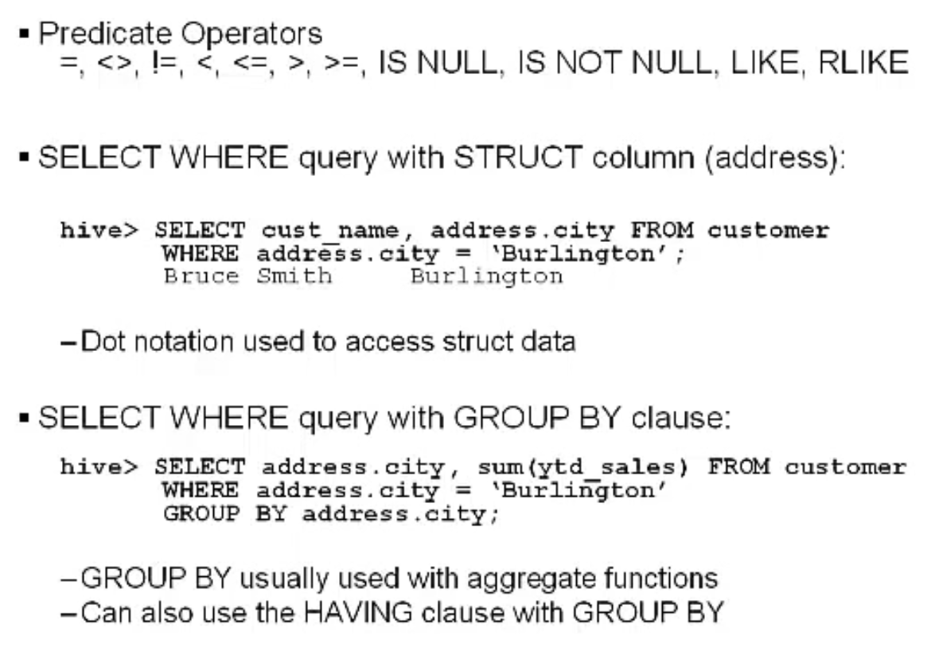

### Column Alias and Nested Select

### SELECT FROM PARTITIONS

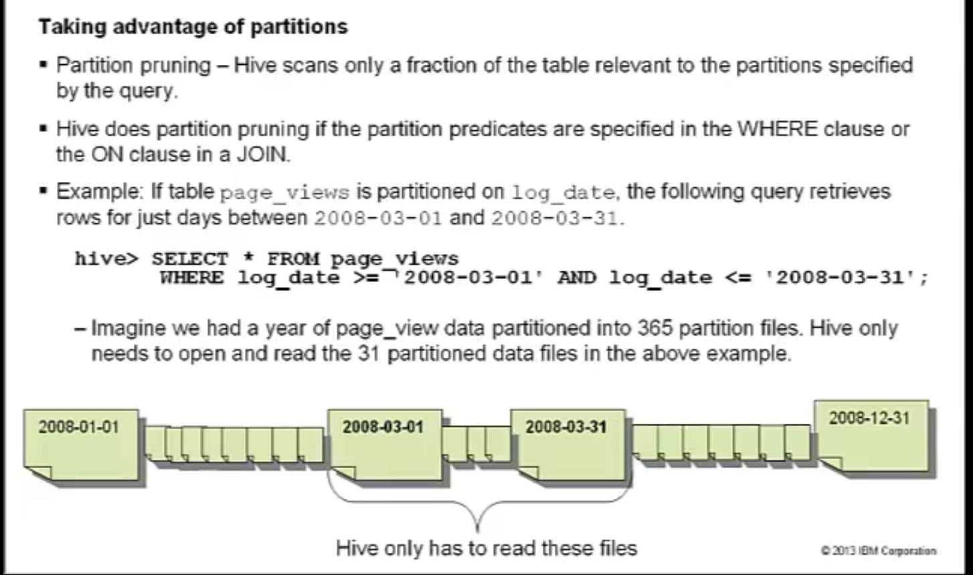

### JOIN

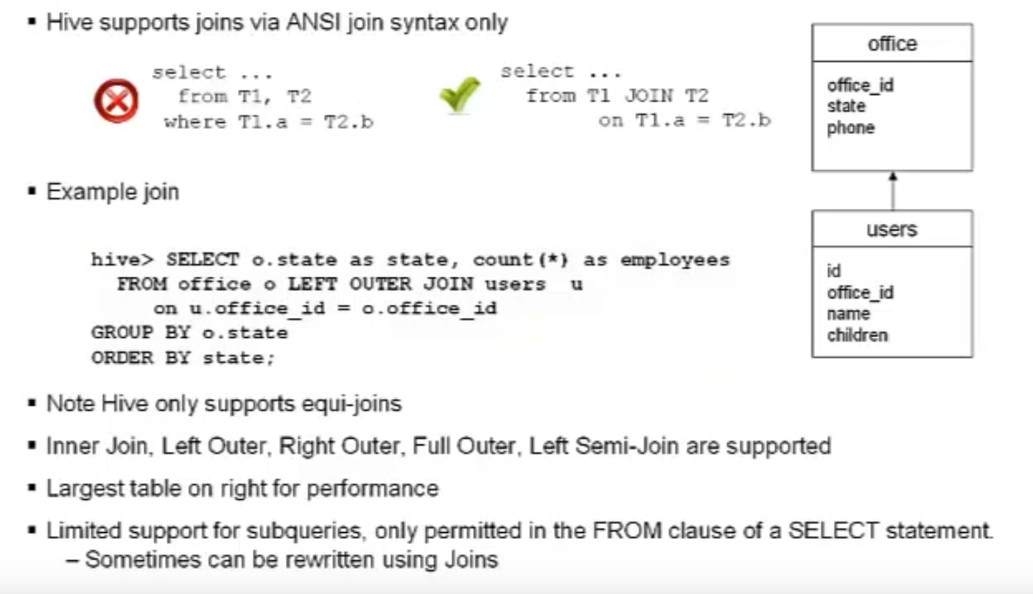

#### Map Join

There’s a variety of Join performance tricks for you to investigate. If at least one of the

Join tables is small, it is possible to do a MapJoin in Hive.

#### Bucket Map Join

If the tables being joined are bucketized on the join columns, and the number of buckets

in one table is a multiple of the number of buckets in the other table, the buckets can be

joined with each other. This is called a Bucket Map Join.

### Order by / Sort by

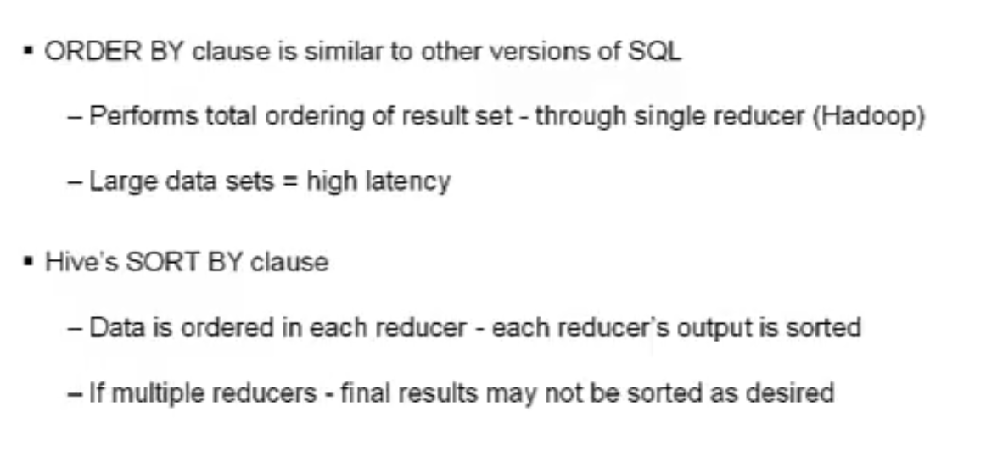

### CASTING

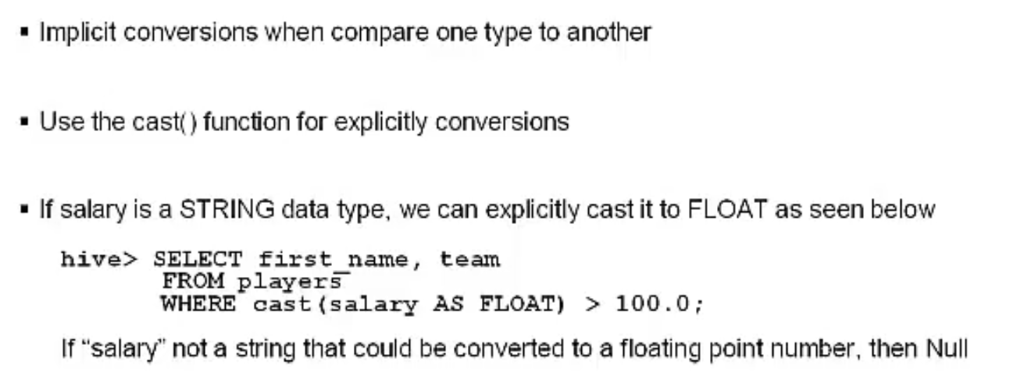

### View

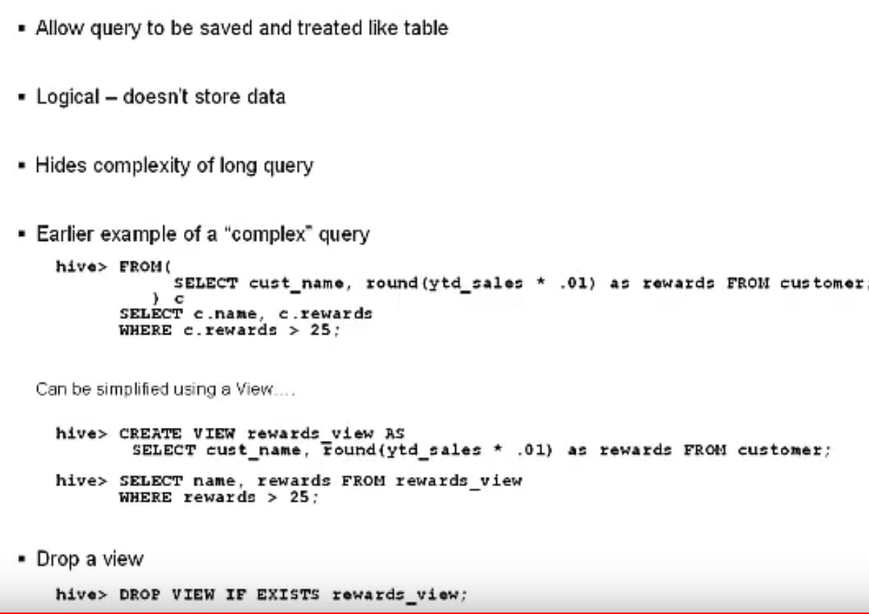

### Explain

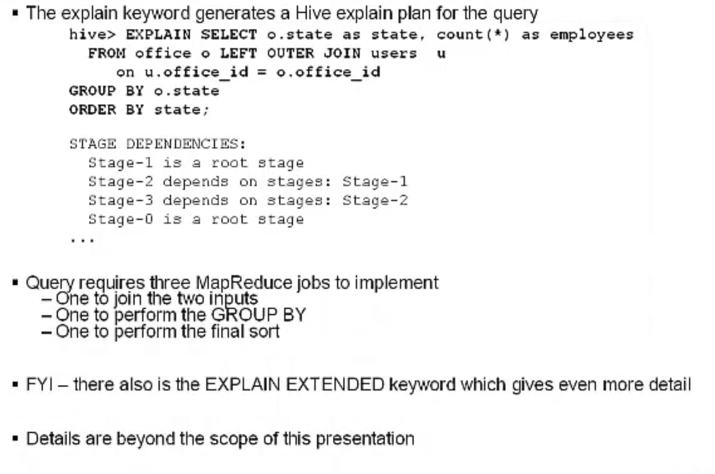

# Hive Operators and Functions

## Use a variety of Hive Operators in your queries

### Relational Operators

Returns a True / False value

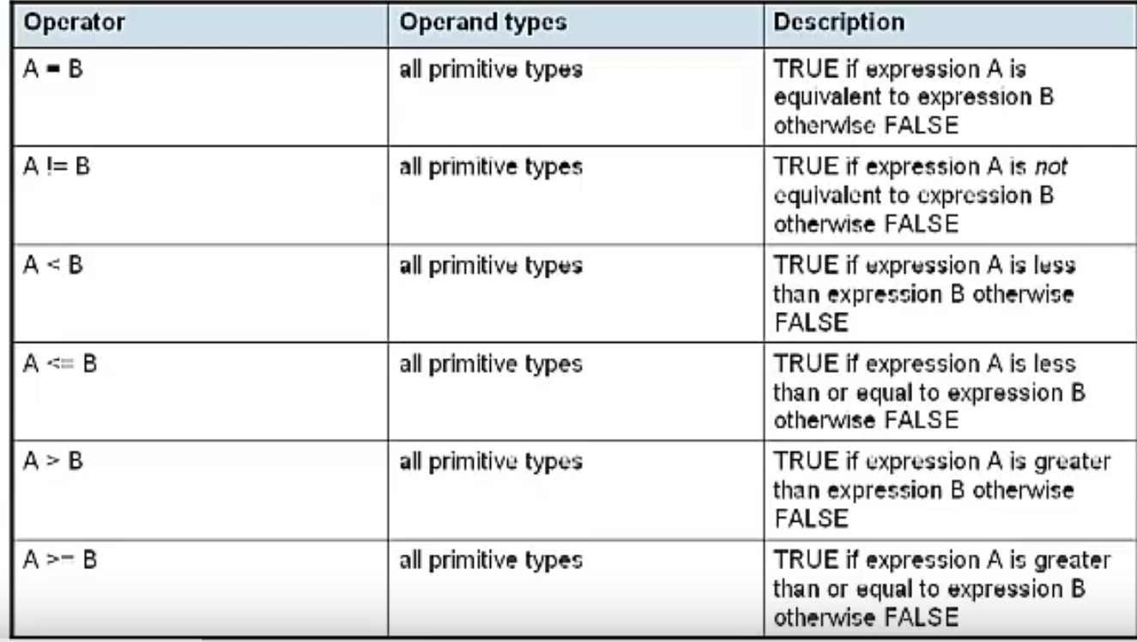

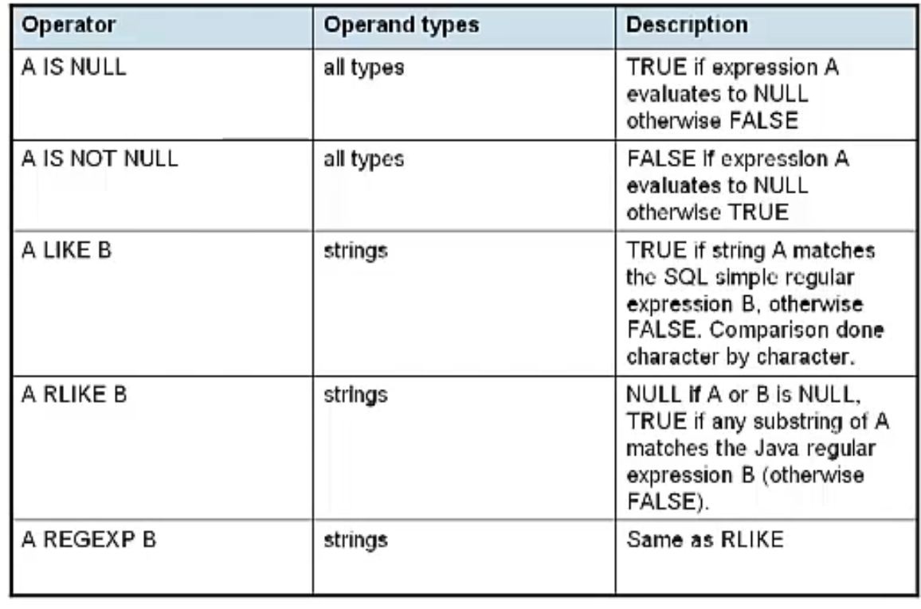

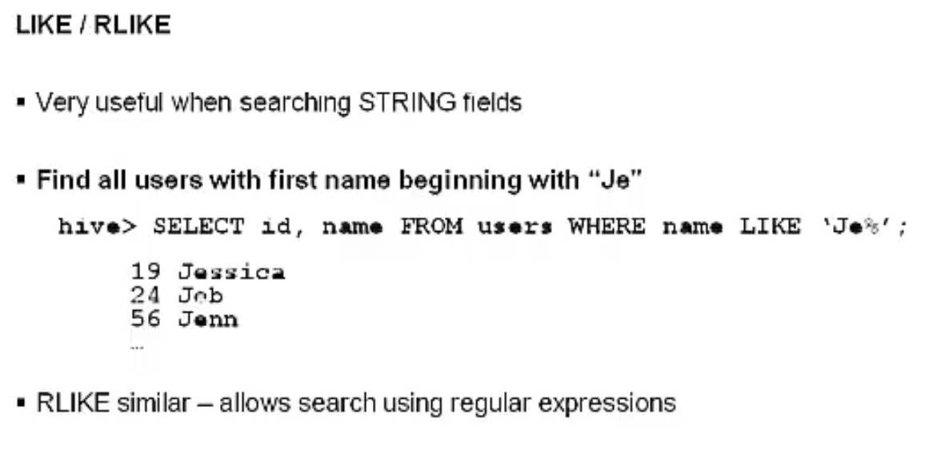

### Arithmetic

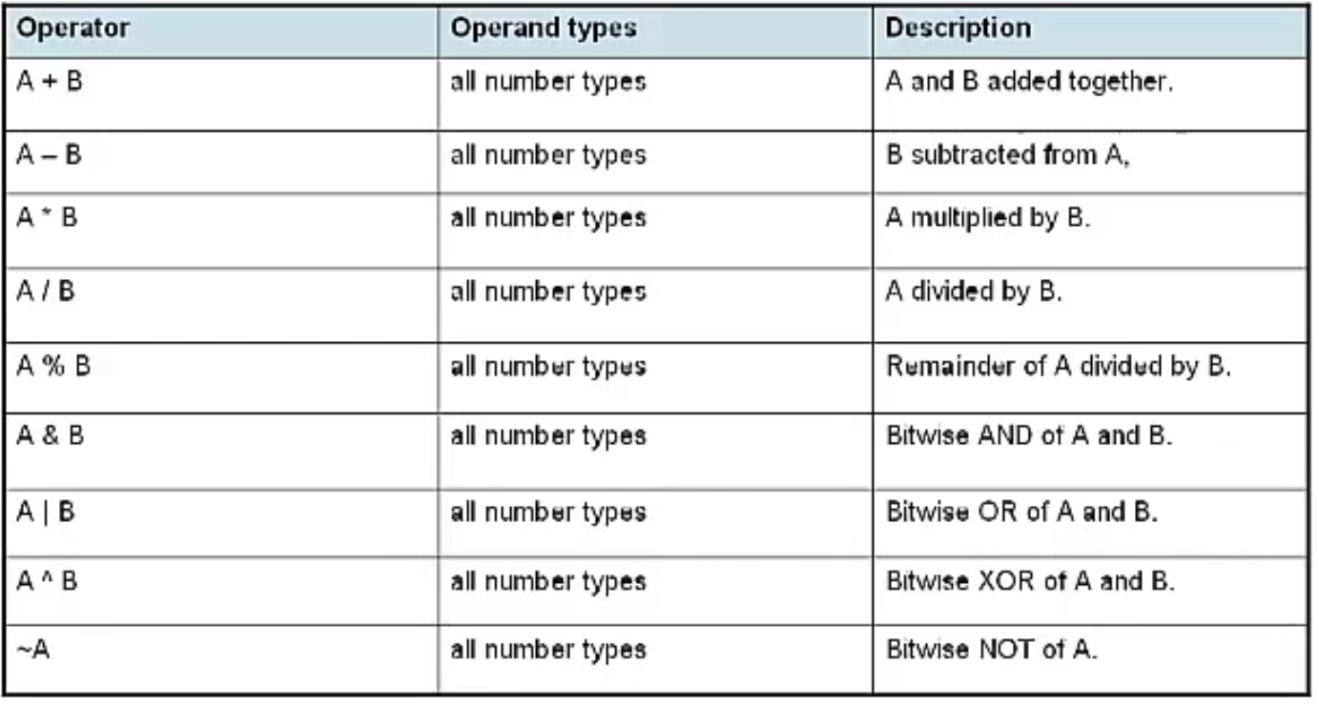

### Logical

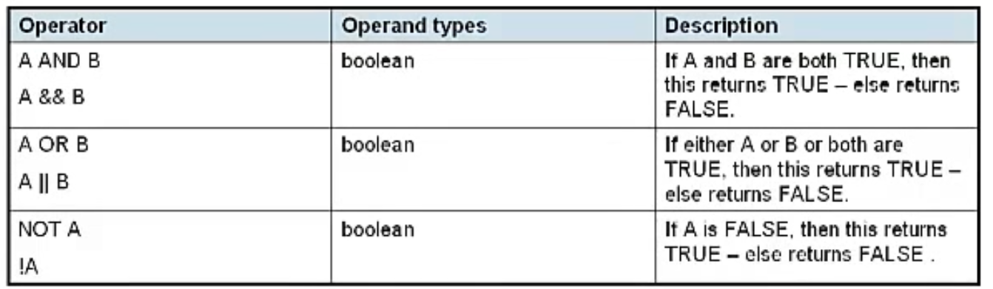

### Complex Type

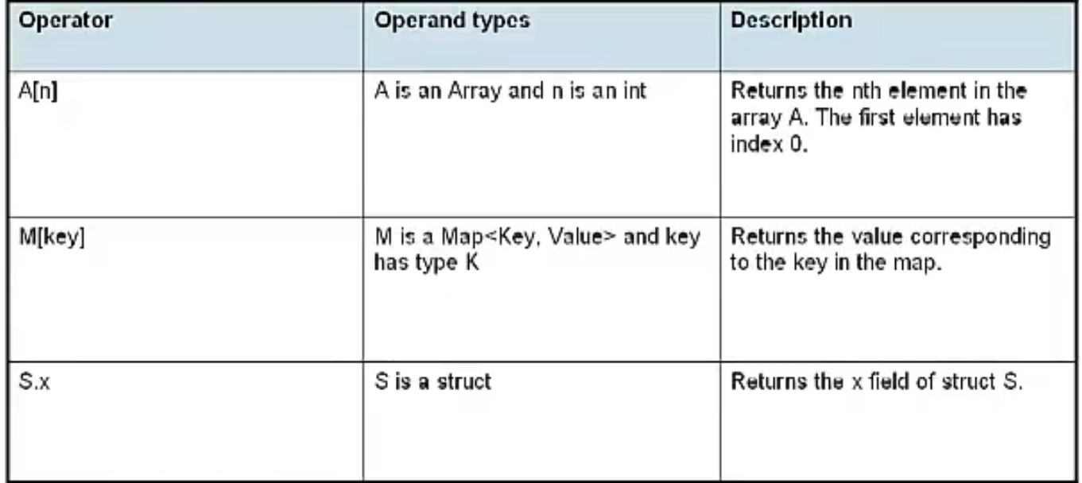

## Utilize Hive’s Built-in Functions

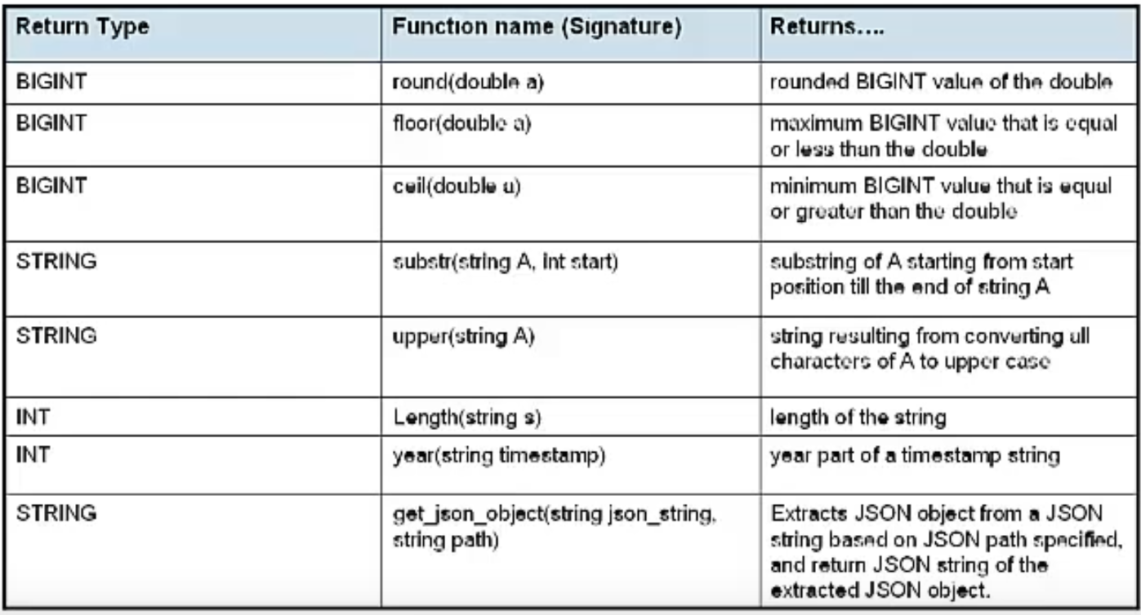

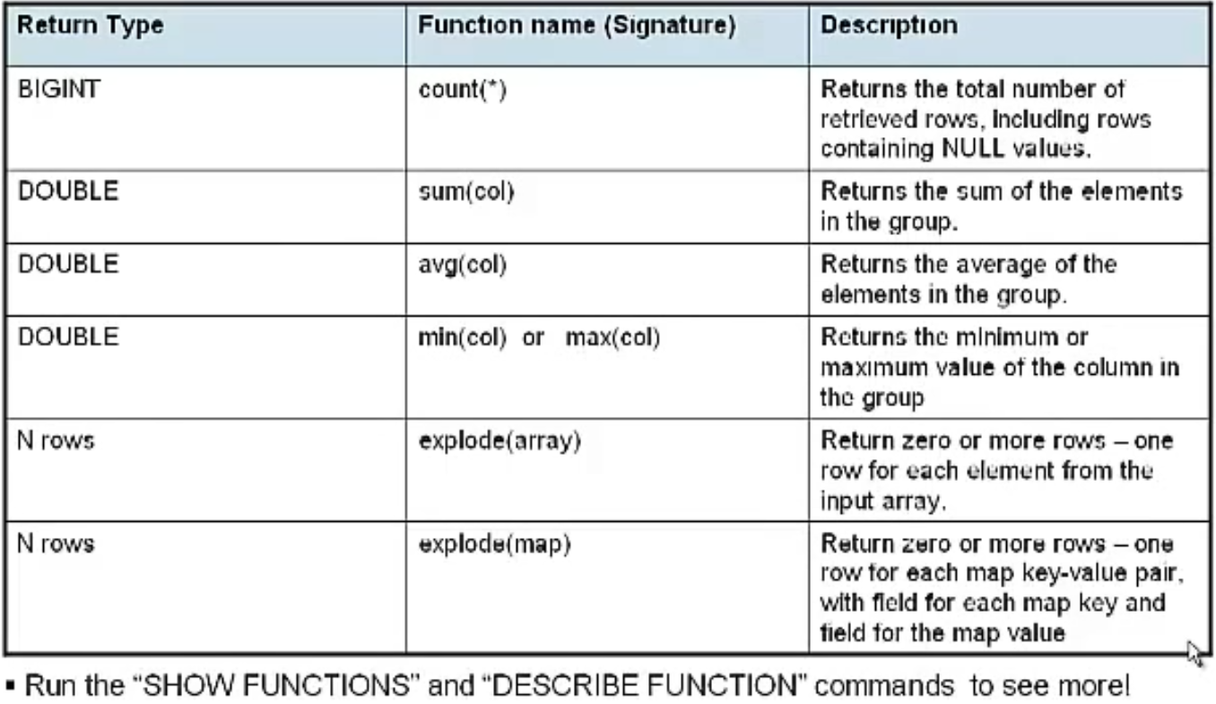

### Windowing and Analytic Functions

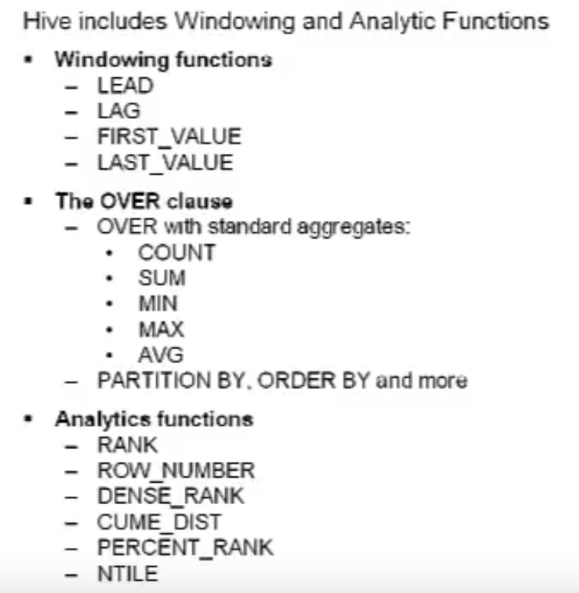

### Examples

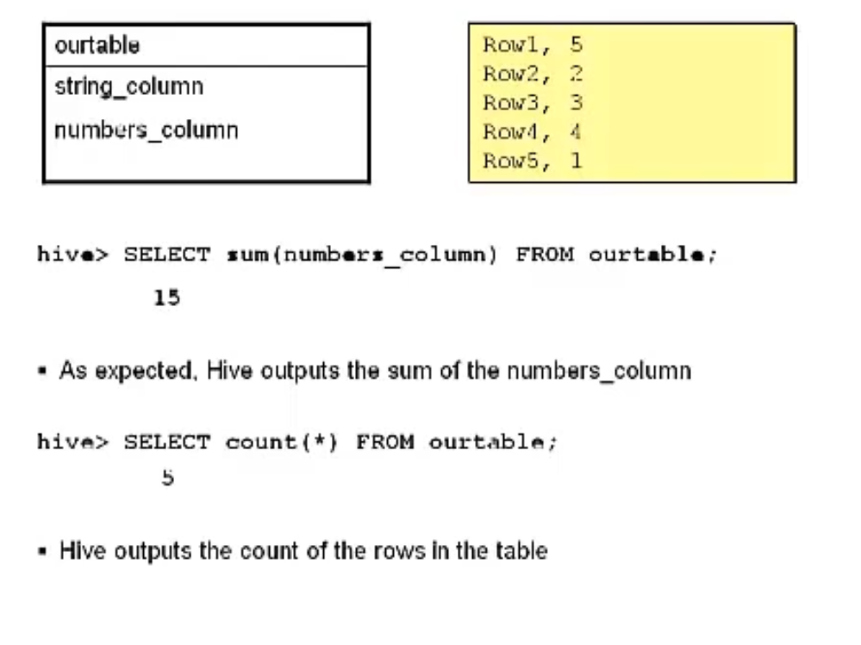

## Explain ways to extend Hive functionality

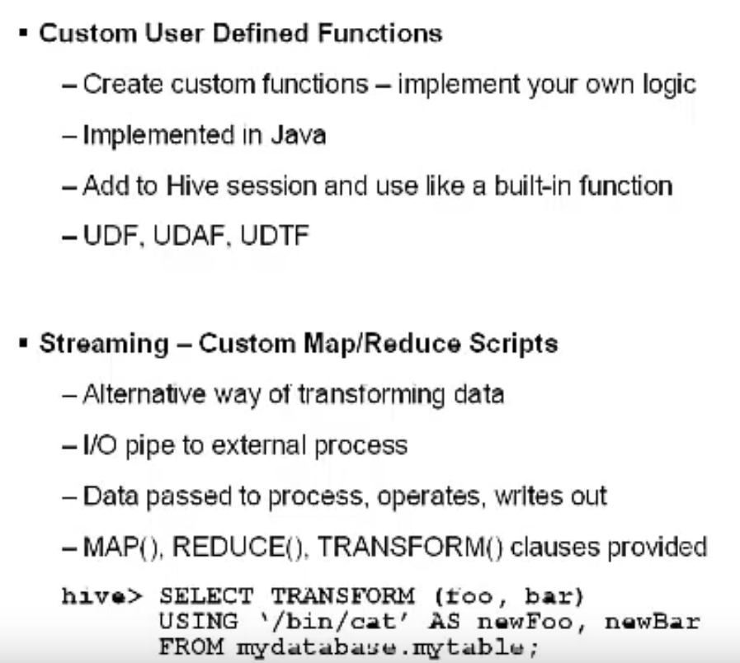

Sometimes in Hive we may want to have some functionality that goes beyond what the

built-in functions provide. One way we can do this is by creating custom user defined

function. UDFs are implemented in Java. Once your UDF Java code is complete you

export it to a JAR file and add it to the Hive session where you can then use the function

the same way you did the built-in functions.

There are 3 different types of user defined functions you can create – regular old UDF’s,

user-defined aggregate functions, and user-defined table generating functions.

Streaming is an alternative way we can transform data using Hive. When we run a

streaming job, data is passed to an external process of our choosing. Our data is read,

processed, and the results are written back out to us. Hive has three clauses - Map,

Reduce, and Transform - that can be used for streaming.

The Streaming example here is a very basic one – we send data to the /bin/cat command

which comes on most Linux systems. The /bin/cat/ command simply echoes the data sent

to it. Hive will get the results back and print them to the CLI.